US 7: COLD WAR STUDY GUIDE

- Why was communism such a worry for the United States after the end of World War II? To what earlier period was it similar?

- Define “interventionism” and “isolationism.” Which policy did the United States follow after WWII?

- What was the “origin” of the Cold War?

- What was the Truman Doctrine? Marshall Plan? What was the MAIN purpose of each?

- What was NATO and what did it show about American foreign policy after WWII?

- Who was Joseph McCarthy, what campaign did he lead and why was he criticized?

- How did President Dwight Eisenhower CHANGE America’s Cold War policy with his “new look” policy?

- How did the new “technology” of television CHANGE American life in the 1950’s?

- What was the “baby boom” and what was a major impact of this event?

- Define the new “youth culture” of the 1950’s and provide three examples.

- What did Michael Harrington show in this book, How the Other Half Lives, 1957?
This book contains photographs, which demonstrate the full impact of tenement life and the living
conditions of New York City's immigrant poor in the late nineteenth century. Look up other photos.

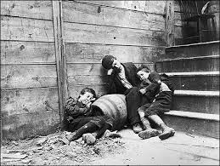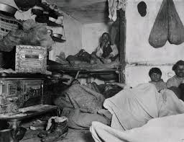

- Describe the aspect of “conformity” in 1950’s America. Why did it exist?

